**R Code for Examples in the book**

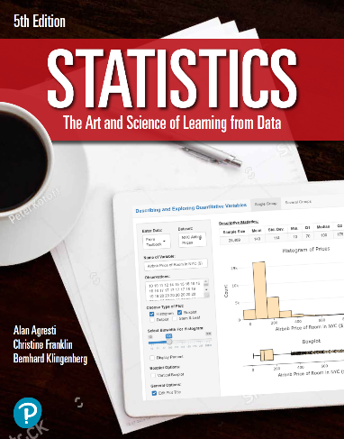

***“Statistics: The Art and Science of Learning from Data”***

**by Agresti, Franklin and Klingenberg, 5th edition**

**Chapter 11**

**Example 3: Happiness and Income – Chi-Squared Statistic**

## Reading in data:

mytable <- as.table(matrix(c(29, 178, 135, 83, 494, 277, 104, 314, 119),   
 nrow = 3, byrow = TRUE,   
 dimnames = list(income =   
 c('above', 'average', 'below'),  
 happy =   
 c('not', 'pretty', 'very'))))  
mytable # viewing the table

## happy  
## income not pretty very  
## above 29 178 135  
## average 83 494 277  
## below 104 314 119

## To perform a chi-squared test, you can use the chisq.test() function

mytest <- chisq.test(mytable)

## To view the chi-squared test statistic

mytest$statistic

## X-squared   
## 54.04308